Login page

Steps to be followed:

Login with your Super Admin Unnati Credentials.

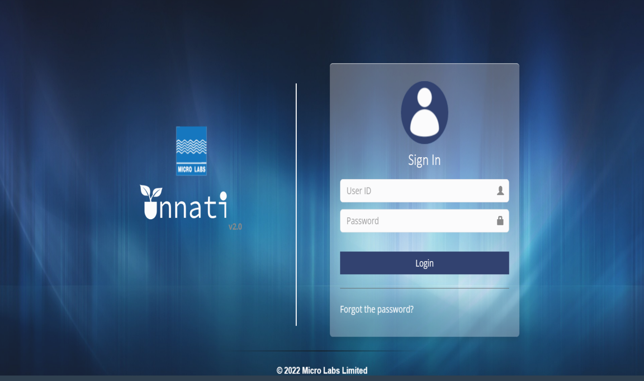

Once loged in will land on home page.

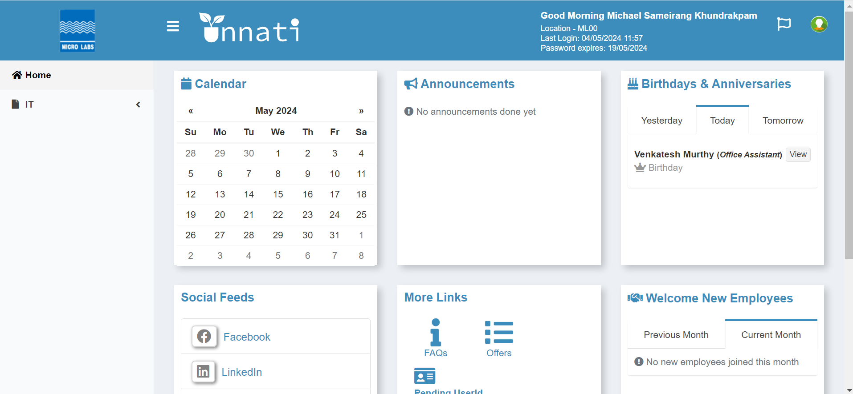

Click on IT on the Dropdown and click on IT Portal.

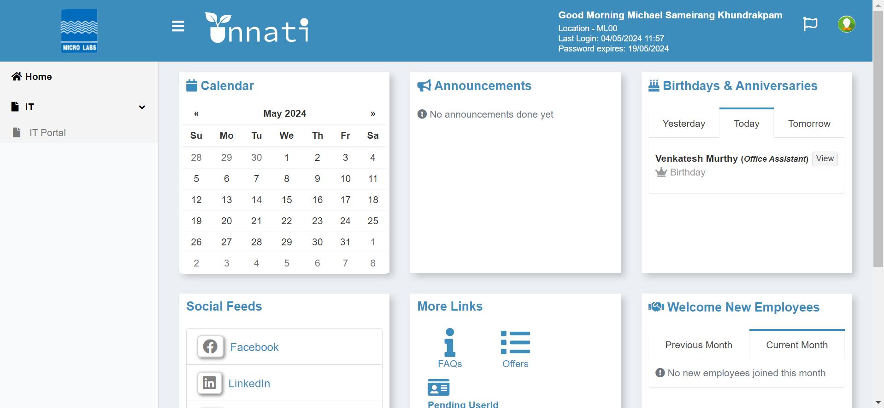

Click on IT Portal Button.

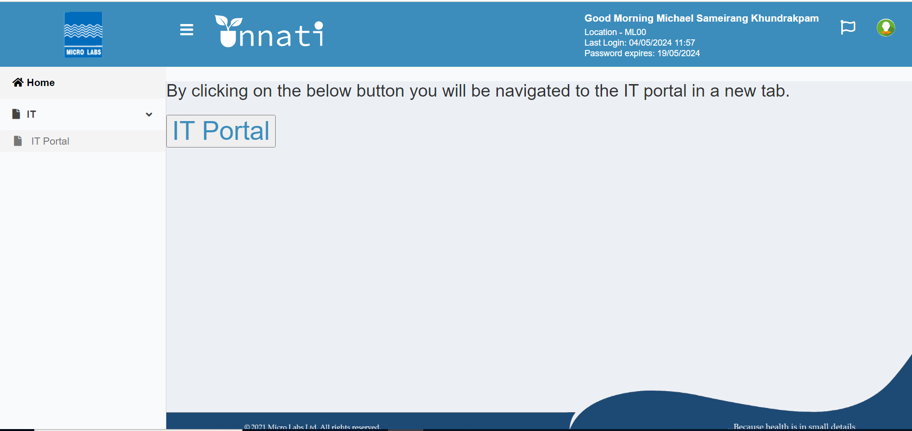

once clicked on IT portal button Dashboard will appear.

